Lab Experiment # 2

Register mode addressing

Calvin Ouellet-Ference
A711643
Mr. Markou
Submitted September 24th 2008
Completed September 23th 2008

1. Objectives

The objectives of the experiment were to familiarize with the basic assembly programming commands to place and move around values in the general registers in both 8-bit and 16-bit versions of the registers.

2. Source Code

2.1. Part 1, 8-Bit:

; PROGRAM: mylab2.ASM
;
; AUTHOR: Calvin O. Ference
;
; DESCRIPTION: This program adds certain HEX values to
; the general registers

ASSUME cs:code

code SEGMENT
main PROC FAR
hajime:
mov ah,0FDh
mov al,8Eh
mov bh,96h
mov bl,66h
mov ch,0A5h
mov cl,0AAh
mov dh,18h
mov dl,9Bh
ate:
mov ax,4C00h
int 21h

main ENDP
code ENDS

END

2.2. Part 1, 16-Bit:

; PROGRAM: mylab2B.ASM
;
; AUTHOR: Calvin O. Ference
;
; DESCRIPTION: This program adds certain HEX values to
; the general registers

ASSUME cs:code

code SEGMENT
main PROC FAR
hajime:
mov ax,0FD8Eh
mov bx,9666h
mov cx,0A5AAh
mov dx,189Bh
shi:
mov ax,4C00h
int 21h

main ENDP
code ENDS

END

2.3. Part 2:

; PROGRAM: mylab2C.ASM
;
; AUTHOR: Calvin O. Ference
;
; DESCRIPTION: This program adds certain HEX values to
; the general registers, then moves them around.

ASSUME cs:code

code SEGMENT
main PROC FAR
hajime:
mov ax,0FD8Eh
mov bx,9666h
mov cx,0A5AAh
mov dx,189Bh
kaze:
mov ch,al
mov al,dl
mov dl,cl
mov cl,bh
mov bh,dl
shi:
mov ax,4C00h
int 21h

main ENDP
code ENDS

END

3. LST Files

3.1. Part 1, 8-Bit:

Microsoft (R) Macro Assembler Version 6.11d 09/17/08 15:13:38
mylab2.asm Page 1 - 1

; PROGRAM: mylab2.ASM
;
; AUTHOR: Calvin O. Ference
;
; DESCRIPTION: This program adds certain HEX values to
; the general registers

ASSUME cs:code

0000 code SEGMENT
0000 main PROC FAR
0000 hajime:
0000 B4 FD mov ah,0FDh
0002 B0 8E mov al,8Eh
0004 B7 96 mov bh,96h
0006 B3 66 mov bl,66h
0008 B5 A5 mov ch,0A5h
000A B1 AA mov cl,0AAh
000C B6 18 mov dh,18h
000E B2 9B mov dl,9Bh
0010 shi:
0010 B8 4C00 mov ax,4C00h
0013 CD 21 int 21h

0015 main ENDP
0015 code ENDS

END

Microsoft (R) Macro Assembler Version 6.11d 09/17/08 15:13:38
mylab2.asm Symbols 2 - 1

Segments and Groups:

N a m e Size Length Align Combine Class

code . . . . . . . . . . . . . . 16 Bit 0015 Para Private

Procedures, parameters and locals:

N a m e Type Value Attr

main . . . . . . . . . . . . . . P Far 0000 code Length= 0015 Public
hajime . . . . . . . . . . . . L Near 0000 code
shi . . . . . . . . . . . . . L Near 0010 code

Symbols:

N a m e Type Value Attr

0 Warnings
0 Errors

3.2. Part 1, 16-Bit:
Microsoft (R) Macro Assembler Version 6.11d 09/17/08 15:18:31
mylab2B.asm Page 1 - 1

; PROGRAM: mylab2B.ASM
;
; AUTHOR: Calvin O. Ference
;
; DESCRIPTION: This program adds certain HEX values to
; the general registers

ASSUME cs:code

0000 code SEGMENT
0000 main PROC FAR
0000 hajime:
0000 B8 FD8E mov ax,0FD8Eh
0003 BB 9666 mov bx,9666h
0006 B9 A5AA mov cx,0A5AAh
0009 BA 189B mov dx,189Bh
000C shi:
000C B8 4C00 mov ax,4C00h
000F CD 21 int 21h

0011 main ENDP
0011 code ENDS

END

Microsoft (R) Macro Assembler Version 6.11d 09/17/08 15:18:31
mylab2B.asm Symbols 2 - 1

Segments and Groups:

N a m e Size Length Align Combine Class

code . . . . . . . . . . . . . . 16 Bit 0011 Para Private

Procedures, parameters and locals:

N a m e Type Value Attr

main . . . . . . . . . . . . . . P Far 0000 code Length= 0011 Public
hajime . . . . . . . . . . . . L Near 0000 code
shi . . . . . . . . . . . . . L Near 000C code

Symbols:

N a m e Type Value Attr

0 Warnings
0 Errors

3.3. Part 2:

Microsoft (R) Macro Assembler Version 6.11d 09/17/08 15:35:44
mylab2C.asm Page 1 - 1

; PROGRAM: mylab2C.ASM
;
; AUTHOR: Calvin O. Ference
;
; DESCRIPTION: This program adds certain HEX values to
; the general registers, then moves them around.

ASSUME cs:code

0000 code SEGMENT
0000 main PROC FAR
0000 hajime:
0000 B8 FD8E mov ax,0FD8Eh
0003 BB 9666 mov bx,9666h
0006 B9 A5AA mov cx,0A5AAh
0009 BA 189B mov dx,189Bh
000C kaze:
000C 8A E8 mov ch,al
000E 8A C2 mov al,dl
0010 8A D1 mov dl,cl
0012 8A CF mov cl,bh
0014 8A FA mov bh,dl
0016 shi:
0016 B8 4C00 mov ax,4C00h
0019 CD 21 int 21h

001B main ENDP
001B code ENDS

END

Microsoft (R) Macro Assembler Version 6.11d 09/17/08 15:35:44
mylab2C.asm Symbols 2 - 1

Segments and Groups:

N a m e Size Length Align Combine Class

code . . . . . . . . . . . . . . 16 Bit 001B Para Private

Procedures, parameters and locals:

N a m e Type Value Attr

main . . . . . . . . . . . . . . P Far 0000 code Length= 001B Public
hajime . . . . . . . . . . . . L Near 0000 code
kaze . . . . . . . . . . . . . L Near 000C code
shi . . . . . . . . . . . . . L Near 0016 code

Symbols:

N a m e Type Value Attr

0 Warnings
0 Errors

4. Results

Highlighted registers (in green) are the register that get affected by the preceding line. Like the first trace shows only the default values that the registers are at before the program starts, none are highlighted as none got affected. The highlighted HEX values (in purple) in the HEX dump at the end of each output file is the machine code associated with the command in the LST output. For part 4.1. screen-shots of DOSBox were taken instead of the TCAP output, the reason behind this is written in the conclusion. For the screen-shots, the values in the purple squares are the affected values while the ones in the blue squares are the machine codes.

4.1. Part 1, 8-Bit Debug Output

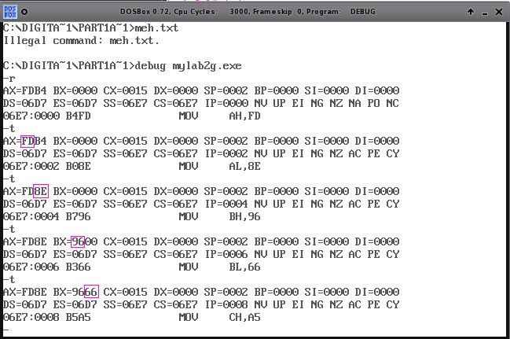
Fig 4.1.1 – First-half of tracing

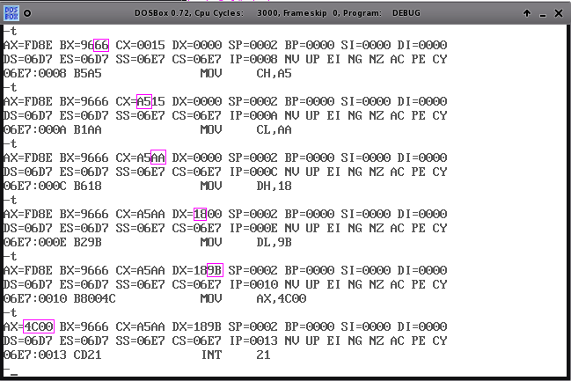
Fig 4.1.2 – Second-half of tracing
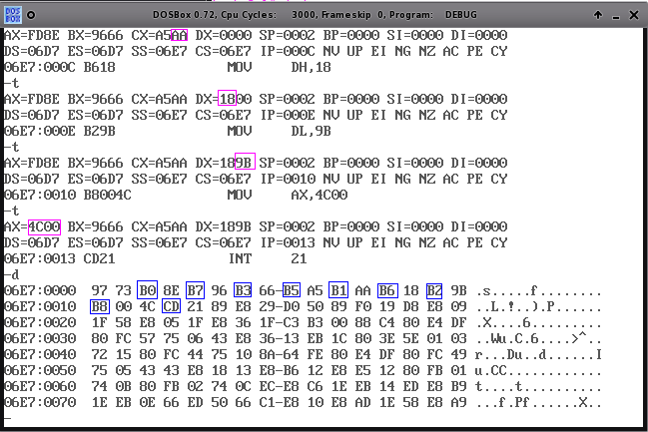
Fig 4.1.3 – Memory Dump

4.2. Part 1, 16-Bit Debug Output

Capture file written by TCAP 3.0, TCAP Copyright(c) 1998 Tim Kannel

C:\MASM>debug mylab2B.exe
-r
AX=0000 BX=0000 CX=0011 DX=0000 SP=0000 BP=0000 SI=0000 DI=0000
DS=0E2B ES=0E2B SS=0E3B CS=0E3B IP=0000 NV UP EI PL NZ NA PO NC
0E3B:0000 B88EFD MOV AX,FD8E
-t

AX=FD8E BX=0000 CX=0011 DX=0000 SP=0000 BP=0000 SI=0000 DI=0000
DS=0E2B ES=0E2B SS=0E3B CS=0E3B IP=0003 NV UP EI PL NZ NA PO NC
0E3B:0003 BB6696 MOV BX,9666
-t

AX=FD8E BX=9666 CX=0011 DX=0000 SP=0000 BP=0000 SI=0000 DI=0000
DS=0E2B ES=0E2B SS=0E3B CS=0E3B IP=0006 NV UP EI PL NZ NA PO NC
0E3B:0006 B9AAA5 MOV CX,A5AA
-t

AX=FD8E BX=9666 CX=A5AA DX=0000 SP=0000 BP=0000 SI=0000 DI=0000
DS=0E2B ES=0E2B SS=0E3B CS=0E3B IP=0009 NV UP EI PL NZ NA PO NC
0E3B:0009 BA9B18 MOV DX,189B
-t

AX=FD8E BX=9666 CX=A5AA DX=189B SP=0000 BP=0000 SI=0000 DI=0000
DS=0E2B ES=0E2B SS=0E3B CS=0E3B IP=000C NV UP EI PL NZ NA PO NC
0E3B:000C B8004C MOV AX,4C00
-t

AX=4C00 BX=9666 CX=A5AA DX=189B SP=0000 BP=0000 SI=0000 DI=0000
DS=0E2B ES=0E2B SS=0E3B CS=0E3B IP=000F NV UP EI PL NZ NA PO NC
0E3B:000F CD21 INT 21
-d
0E3B:0000 B8 8E FD BB 66 96 B9 AA-A5 BA 9B 18 B8 00 4C CD ....f.........L.
0E3B:0010 21 03 CA B8 00 4C CD 21-8A D0 8A F3 B8 00 4C CD !....L.!......L.
0E3B:0020 21 57 56 8B 46 0A 2D C8-00 74 07 48 48 74 30 E9 !WV.F.-..t.HHt0.
0E3B:0030 80 00 8B 76 0C 68 B2 16-FF 36 E8 40 E8 87 9A 68 ...v.h...6.@...h
0E3B:0040 FF 00 6A 00 68 B2 16 8B-DE B8 01 00 BA 06 00 E8 ..j.h...........
0E3B:0050 DA 22 56 A1 E6 40 05 03-00 50 E8 23 23 EB 53 8B ."V..@...P.##.S.
0E3B:0060 7E 0C 6A 00 6A 00 6A 00-8B DF B8 01 00 BA 05 00 ~.j.j.j.........
0E3B:0070 E8 B9 22 50 E8 2D 86 5B-8B F0 E8 07 A1 3B C6 74 .."P.-.[.....;.t
-q

C:\MASM>tcap/u

4.3. Part 2

Capture file written by TCAP 3.0, TCAP Copyright(c) 1998 Tim Kannel

C:\MASM>debug mylab2C.exe
-r
AX=0000 BX=0000 CX=001B DX=0000 SP=0000 BP=0000 SI=0000 DI=0000
DS=0E2B ES=0E2B SS=0E3B CS=0E3B IP=0000 NV UP EI PL NZ NA PO NC
0E3B:0000 B88EFD MOV AX,FD8E
-t

AX=FD8E BX=0000 CX=001B DX=0000 SP=0000 BP=0000 SI=0000 DI=0000
DS=0E2B ES=0E2B SS=0E3B CS=0E3B IP=0003 NV UP EI PL NZ NA PO NC
0E3B:0003 BB6696 MOV BX,9666
-t

AX=FD8E BX=9666 CX=001B DX=0000 SP=0000 BP=0000 SI=0000 DI=0000
DS=0E2B ES=0E2B SS=0E3B CS=0E3B IP=0006 NV UP EI PL NZ NA PO NC
0E3B:0006 B9AAA5 MOV CX,A5AA
-t

AX=FD8E BX=9666 CX=A5AA DX=0000 SP=0000 BP=0000 SI=0000 DI=0000
DS=0E2B ES=0E2B SS=0E3B CS=0E3B IP=0009 NV UP EI PL NZ NA PO NC
0E3B:0009 BA9B18 MOV DX,189B
-t

AX=FD8E BX=9666 CX=A5AA DX=189B SP=0000 BP=0000 SI=0000 DI=0000
DS=0E2B ES=0E2B SS=0E3B CS=0E3B IP=000C NV UP EI PL NZ NA PO NC
0E3B:000C 8AE8 MOV CH,AL
-t

AX=FD8E BX=9666 CX=8EAA DX=189B SP=0000 BP=0000 SI=0000 DI=0000
DS=0E2B ES=0E2B SS=0E3B CS=0E3B IP=000E NV UP EI PL NZ NA PO NC
0E3B:000E 8AC2 MOV AL,DL
-t

AX=FD9B BX=9666 CX=8EAA DX=189B SP=0000 BP=0000 SI=0000 DI=0000
DS=0E2B ES=0E2B SS=0E3B CS=0E3B IP=0010 NV UP EI PL NZ NA PO NC
0E3B:0010 8AD1 MOV DL,CL
-t

AX=FD9B BX=9666 CX=8EAA DX=18AA SP=0000 BP=0000 SI=0000 DI=0000
DS=0E2B ES=0E2B SS=0E3B CS=0E3B IP=0012 NV UP EI PL NZ NA PO NC
0E3B:0012 8ACF MOV CL,BH
-t

AX=FD9B BX=9666 CX=8E96 DX=18AA SP=0000 BP=0000 SI=0000 DI=0000
DS=0E2B ES=0E2B SS=0E3B CS=0E3B IP=0014 NV UP EI PL NZ NA PO NC
0E3B:0014 8AFA MOV BH,DL
-t

AX=FD9B BX=AA66 CX=8E96 DX=18AA SP=0000 BP=0000 SI=0000 DI=0000
DS=0E2B ES=0E2B SS=0E3B CS=0E3B IP=0016 NV UP EI PL NZ NA PO NC
0E3B:0016 B8004C MOV AX,4C00
-t

AX=4C00 BX=AA66 CX=8E96 DX=18AA SP=0000 BP=0000 SI=0000 DI=0000
DS=0E2B ES=0E2B SS=0E3B CS=0E3B IP=0019 NV UP EI PL NZ NA PO NC
0E3B:0019 CD21 INT 21
-d
0E3B:0000 B8 8E FD BB 66 96 B9 AA-A5 BA 9B 18 8A E8 8A C2 ....f...........
0E3B:0010 8A D1 8A CF 8A FA B8 00-4C CD 21 C2 06 00 55 8B ........L.!...U.
0E3B:0020 EC 57 56 8B 46 0A 2D C8-00 74 07 48 48 74 30 E9 .WV.F.-..t.HHt0.
0E3B:0030 80 00 8B 76 0C 68 B2 16-FF 36 E8 40 E8 87 9A 68 ...v.h...6.@...h
0E3B:0040 FF 00 6A 00 68 B2 16 8B-DE B8 01 00 BA 06 00 E8 ..j.h...........
0E3B:0050 DA 22 56 A1 E6 40 05 03-00 50 E8 23 23 EB 53 8B ."V..@...P.##.S.
0E3B:0060 7E 0C 6A 00 6A 00 6A 00-8B DF B8 01 00 BA 05 00 ~.j.j.j.........
0E3B:0070 E8 B9 22 50 E8 2D 86 5B-8B F0 E8 07 A1 3B C6 74 .."P.-.[.....;.t
-q

C:\MASM>tcap/u

5. Conclusion

Due to either a glitch or that the user was at fault; the TCAP output for section 4.1 were lost and/or not recorded. A second mistake was performed by the user which made the debug program unavailable at the time the report was written. The remedy to this problem was to install DOSBox and then go download the debug.com file from the freedos projects website, also, the logic behind using DOSBox instead of the built-in DOS emulator under a Windows operating system was because no x86 operating systems were available at the time of this report being written which, because of the compatibility issues between x86 software and the x64 environment. Nonetheless, the experiment was successful and the objectives were completed.

